Monetary Policy and Economic Activity in the Republic of Korea:

A Structural VAR Approach

## Introduction

In this paper, I propose an answer to the question of whether or not monetary policy has an effect on real output growth for the Republic of Korea. I use the Sims (1980) proposed solution and the theoretical assumption that comes with it to measure the structural impulse response of output to a shock in the interest rate.

Through a vector autoregression (VAR) approach, I aim to show that changes in the short-term nominal interest rate due to monetary policy cause GDP growth to negatively change in the Republic of Korea. An unexpected shock to the interest rate from the monetary authority of South Korea, has a negative effect on output growth 1 quarter after the shock. The effect during quarter 1 is short-lived, but returns in quarters 8 to 10.

A main limitation my interpretation faces is the lack of explanation of what is behind a monetary policy shock to the interest rate.

## Monetary Policy Effectiveness: Theory and Empirical Challenges

The nominal interest rate selected by a country’s monetary authority will eventually impact economic activity (the growth rate of real gross domestic product). This is accomplished through the channel of aggregate demand, specifically aggregate investment. Generally, a change in the short-term interest rate affects the growth rate because the interest rate alters the demand for investment, which consequently alters aggregate investment, which changes aggregate demand, and therefore the growth rate of real GDP.

The real economy consists of borrowers and savers both of which care about the interest rate in which they can borrow and save. It is through borrowers and savers that the nominal interest rate has an effect on the real economy. If a borrower demands funds to purchase either new machines, durables, or housing, they will approach a big bank that can lend them money at some interest rate iB, the interest rate on borrowing. If a saver wants a higher income in the future to purchase new machines, durables, or housing, they will deposit money in a big bank to get a return on those savings at some interest rate iS, the interest rate on savings. The same change in the interest rate has an opposing effect for borrowers and savers. If there is an increase in the nominal interest rate, that is bad for borrowers as the cost of borrowing has risen, but good for savers as the return from saving has increased. Hence, whether monetary policy, by determining a short-run nominal interest rate, has a positive or negative effect on an economy’s real GDP is a macroeconomic question worth exploring.

Whether someone is a borrower or a saver, the same change in nominal interest rate is going to have either a positive or negative effect on aggregate demand. A given change in the interest rate can result in savers dominating the overall effect, or borrowers doing so. Trying to measure the net effect between these two possibilities is an empirical challenge because there is a simultaneous relationship between the central bank that selects the interest rate and the real economy that reacts to it. When the central bank changes in the interest rate, there is a domino effect that travels through the interbank interest rate iIB, the interest rate at which big banks borrow with each other, and then to iB and iS. This is the connection between policy and the real economy which I will call αi, the impact of a change in the interest rate on the current growth rate. The central bank is concurrently monitoring the real economy, meaning their selection of an interest rate depends on the state or performance of the real economy. I will call this αy, the contemporaneous effect of the growth rate on the policy rate. This leads to reverse causality; the real economy acts in accordance with changes in the interest rate the central bank makes and the central bank looks to the real economy to decide on a nominal interest rate. This simultaneous causality causes difficulty in answering the question of whether or not monetary policy affects the real economy.

To provide a solution to the question, I will need to compute the structural impulse response of output to a shock in the interest rate. The simultaneous causality problem that is essentially a roadblock to an answer has a solution in the form of the Sims (1980) method.

Using the Sims (1980) approach, via the Cholesky decomposition, requires that I place a theoretical restriction on my model — I must impose the assumption that one of the contemporaneous effects is equal to zero. The previously mentioned αi, the impact of a change in the interest rate on the current growth rate, must be zero in order for me to measure the structural impulse response. By making this assumption, I am stating any contemporaneous policy changes have no contemporaneous effect on output. That is, any current changes to the interest rate have no effect on current output. If the interest rate were to change today at this moment, the impact of the change on GDP growth today would be zero. There would be none. Consequently, I am making the assumption that it takes at least one quarter for a change in the interest rate policy to have any effect on aggregate demand.

This is a reasonable assumption to make because decisions about the interest rate do not directly affect borrowers and savers. Referring to the domino effect I mentioned earlier, the metaphorical central bank domino does not directly precede the borrowers and savers domino; the big bank dominoes stand between them. Borrowers and savers take time to adjust their aggregate demand decisions when the interest rate changes. Even if they are able to make immediate decisions, actions they may choose to take, like purchase a new house or machinery, take time to come to fruition. For this reason, to assume that a policy change can have a delayed effect on output growth is a reasonable one to make.

## Data and VAR Estimation

The data I use is the gross domestic product by expenditure in constant prices and the 3-month/90-day rates and yields for the Republic of Korea, to look at the real GDP and short-term nominal interest rate. Data is gathered from the Federal Reserve Bank of St. Louis website.[[1]]

The GDP is seasonally adjusted and reported quarterly in units of the national currency (the South Korean won). The data I make use of starts at the beginning of the first quarter of 1991 (1991-01-01) and stops at the beginning of the first quarter of 2020 (2020-01-01). Including the economic activity shocks that result from the COVID-19 period may lead to inaccurate conclusions; thus, I prevent this issue by removing data from the COVID period.

|  |  |  |  |  |  |
| --- | --- | --- | --- | --- | --- |
| Minimum | 1st Quartile | Median | Mean | 3rd Quartile | Maximum |
| -28.246 | 2.455 | 4.668 | 4.681 | 7.478 | 17.159 |

The short-term nominal interest rate is not seasonally adjusted and reported quarterly as a percentage. I make use of short-term nominal interest data from the first quarter of 1991 (1991-01-01) to the beginning of the first quarter of 2020 (2020-01-01). Through limiting some of the data I use, the possible issue of inaccuracy due to the inclusion of COVID period shocks is prevented, and both data sets share the same time window.

|  |  |  |  |  |  |
| --- | --- | --- | --- | --- | --- |
| Minimum | 1st Quartile | Median | Mean | 3rd Quartile | Maximum |
| 1.350 | 2.653 | 4.577 | 6.592 | 11.623 | 22.723 |

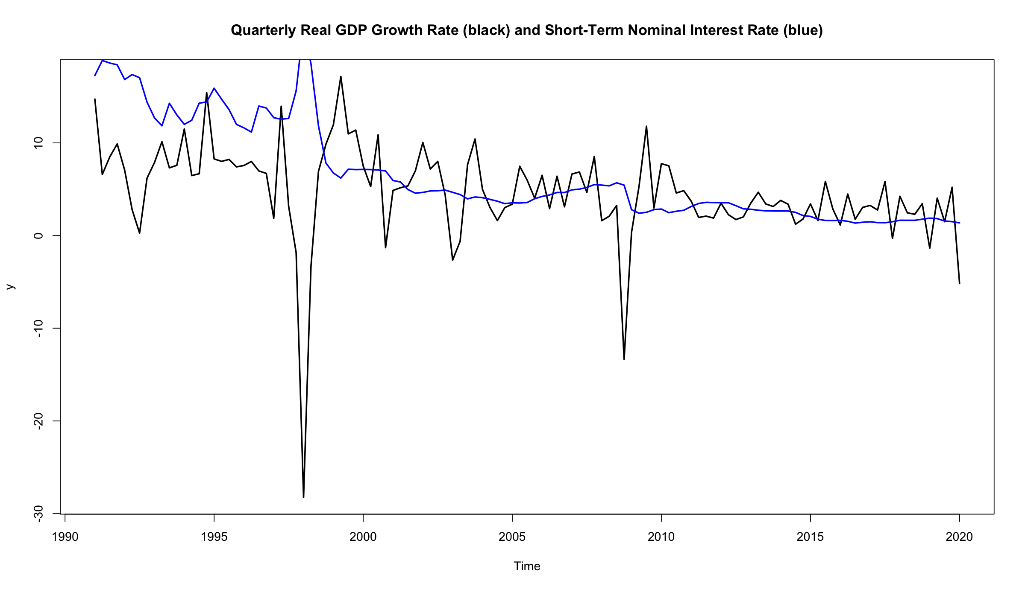

I determine my preferred VAR specification by computing information criteria. Information criteria are used to evaluate possible specifications and account for the bias-variance tradeoff. In choosing a specification, there is a key tradeoff between bias and variance. Selecting a specification that is too small results in bias, as variables that contribute to explaining the model could be omitted. If the specification is too big, however, this leads to an issue of a large variance, or standard error. This tradeoff is captured by the Akaike information criterion (AIC) and the Schwarz criterion (also known as the Bayes information criterion). Each equation of these information criteria have a penalty on the addition of a parameter. The specification that minimizes the AIC and SC should be selected. The specification that minimizes the AIC can differ from the one that minimizes the SC. In this case, it is helpful to recognize that the SC is more parsimonious, in that it prefers the selection of smaller lags, than the AIC by design. If the AIC and SC are in agreement with a number of lags, then there is good confidence in said amount.

In computing information criteria, I choose a maximum of 15 lags to make sure that I would not be cutting off a VAR specification that the information criteria have calculated.

|  |  |  |  |
| --- | --- | --- | --- |
| AIC(n) | HQ(n) | SC(n) | FPE(n) |
| 7 | 2 | 2 | 7 |

The AIC reports that the VAR specification should be 7 lags, while the SC points to 2 lags. Again, the SC is more conservative in the number of lags it suggests. Using 2 lag may not ensure that I will catch any interdependence that may exist. Yet, selecting 7 lags results in more parameters that need to be estimated (7 lags multiplied by a 4x4 matrix = 28 parameters, with data sets of 117 observations). These contrasting decisions underscore the bias-variance tradeoff. If I were using the VAR for forecasting, it would benefit me more to be more parsimonious in my selection. With attempting to determine whether or not monetary policy has an effect on real output growth, I am using the VAR for causality analysis and may want to use more than just 2 lags. Therefore, I will comply with the AIC and use 7 lags.

The variance-covariance matrix of residuals that result from choosing 7 lags shows that the innovations are contemporaneously correlated.

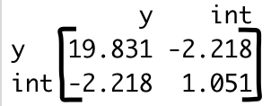

A check for covariance stationarity (i.e. computing the eigenvalues of the companion form matrix) shows that the root values are all less than 1, indicating that the VAR is stationary.

|  |  |  |  |  |  |  |
| --- | --- | --- | --- | --- | --- | --- |
| 0.9796552 | 0.8678023 | 0.8678023 | 0.8587964 | 0.8587964 | 0.7945421 | 0.7945421 |
| 0.7538973 | 0.7493446 | 0.7493446 | 0.7453642 | 0.7453642 | 0.6961868 | 0.6961868 |

A plot of fit and residuals for the real GDP growth rate shows that the selection of 7 lags is a good fit.

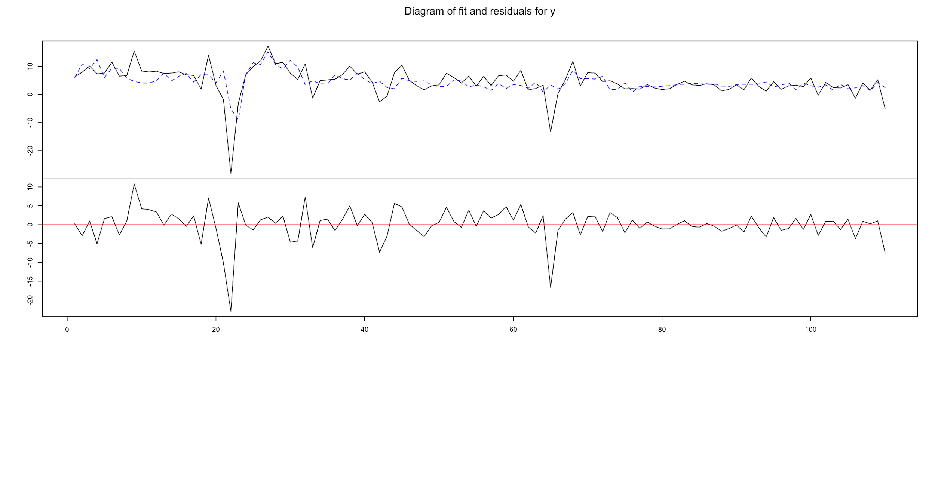

## Is Monetary Policy Effective?

By assuming αi, the impact of a change in the interest rate on the current growth rate, is equivalent to zero and believing the correct VAR specification is a choice of 7 lags, my results say monetary policy has a negative effect on output growth. Looking at the structural impulse response using the aforementioned Sims solution (via the Cholesky decomposition that “triangularizes” the residuals by setting αi to zero) leads me to this conclusion.

A scan of the impulse response of output and short-term interest rate to a change in the output shock tells me that the behavior of the impulse responses are reasonable. A negative shock in output is paired with an increase in the interest rate, possibly an act on the central bank’s part to combat the effects of lower output growth.

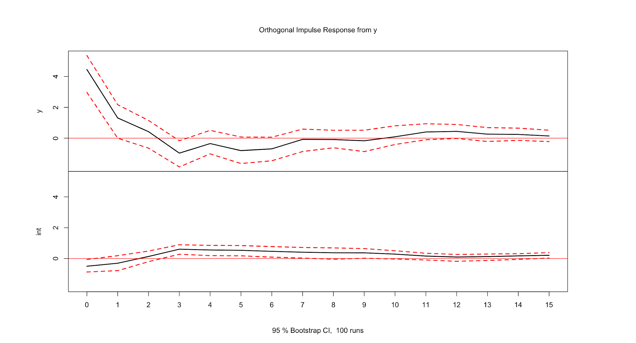

The answer to the question of whether or not monetary policy has a positive or negative effect on an economy’s real GDP is found in the structural impulse response of output to an interest rate shock.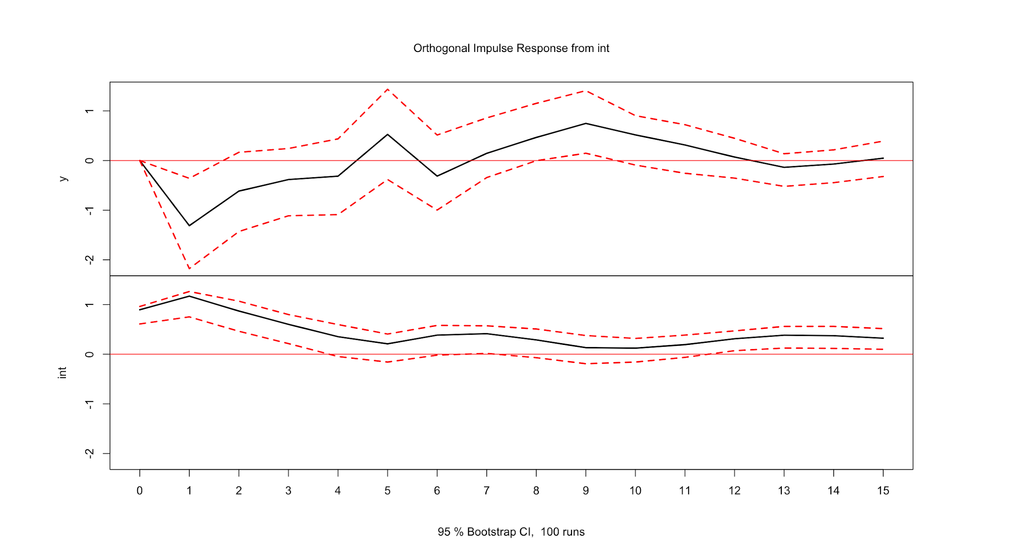

An unexpected shock to the interest rate from the Bank of Korea, the central bank of South Korea, has a negative effect on output growth 1 quarter after the shock. At 2 quarters, we cannot reject the null hypothesis of the impulse response being zero. It is the same for the following quarters until quarter 7. From quarters 8 to 10, an unexpected shock to the interest rate due to monetary policy has a negative effect on output growth again. The effect during quarter 1 is short-lived, but returns in quarters 8 to 10.

## Discussion of Limitations and Robustness

A main limitation my interpretation faces is the lack of explanation of what is behind a monetary policy shock to the interest rate. Monetary authorities and economists alike do not have definite ideas about what a monetary policy shock to the interest rate should be (Ramey 2016).[[2]] Therefore, interpretations of why a certain nominal interest rate selected by a country’s central bank will positively or negatively impact the growth rate of real GDP are limited. This limitation may also make attempts to forecast the impact of a change in the interest rate on output growth an arduous task.

As for robustness, I felt that the gap between the 2 and 7 lags the SC and AIC suggested, respectively, was somewhat large. In a test to see if my selection of 7 lags was robust, I tested lags 2, 4, and 5 to see if I would come to the same conclusion as I did by choosing 7 lags. All these lags resulted in a negative impulse response at quarter 1, the same result I arrived at with 7 lags. So, quarter 1 is robust to the order of the VAR specification.

1. [Federal Reserve Economic Data | FRED | St. Louis Fed](https://fred.stlouisfed.org)
2. Ramey (2016), pg. 24